# Project Proposal

Project Description

Name: 112 Racing

Description: a 2d car racing game with real world physics and AI competitors

Competitive Analysis

Similar projects like <https://www.youtube.com/watch?v=L3ktUWfAMPg> only have simple physics and simple game AI. Compared to this one, my game will have more real physics engine and smarter AI. Moreover, the users can even draw their own map and race on that.

Structural Plan

main.py for drawing

car.py for creating Car class

track.py for creating Track class

polygonToList.py and isInsideTrack.py for detecting boundaries

gameAI.py for creating gameAI

Algorithmic Plan

1. Car physics:
   1. Linear acceleration:
      1. press throttle -> get max engineTorque under current rpm -> calculate drive force
      2. not press throttle-> 0 drive force

drive force + drag force + rolling assistance ->get acceleration change ->velocity change ->position change and rpm change

* 1. Linear brake:

brake force + drag force + rolling assistance ->get acceleration change ->velocity change ->position change and rpm change

1. Game AI

Timeline Plan

TP1: finish basic car physics part (linear)

TP2: finish game AI part

Version Control Plan

Back up file both in my external hard drive and Google drive.

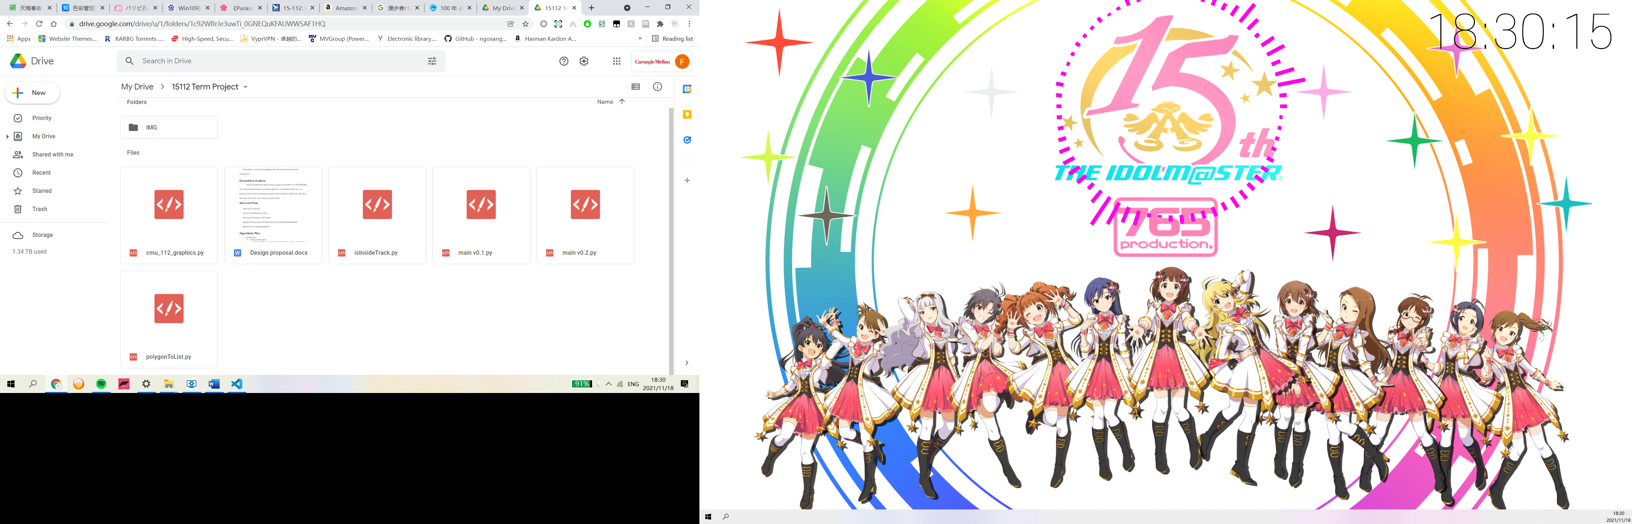

Module List

pillow, opencv, numpy

 TP2 Update

Algorithmic Plan：

Game AI: use backtracking method with large step to generate route. Use helper function to calculate midpoint to make route smoother.

Timeline Plan

TP1: finish basic car physics part (linear)

TP2: finish game AI part

TP3 Update

Changes on UI to improve user experiences